**Exploratory Data Analysis**

**Instructions:**

Please share your answers filled in-line in the word document. Submit code separately wherever applicable.

Please ensure you update all the details:

**Name: _____________ Batch ID:** ___________

**Topic: Exploratory Data Analysis**

**Guidelines:**

**1. An assignment submission is considered complete only when correct and executable code(s) are submitted along with the documentation explaining the method and results. Failing to submit either of those will be considered an invalid submission and will not be considered as correct submission.**

**2. Ensure that you submit your assignments correctly. Resubmission is not allowed.**

**3. Post the submission you can evaluate your work by referring to keys provided. (will be available only post the submission).**

**Hints: Follow CRISP-ML(Q) methodology steps, where were appropriate.**

1. **Data Understanding: work on each feature of the dataset to create a data dictionary as displayed in the image below:**

**Make a table as shown above and provide information about the features such as its data type and its relevance to the model building. And if not relevant, provide reasons and a description of the feature.**

**Problem Statements:**

Q1) Calculate Skewness, Kurtosis using R/Python code & draw inferences on the following data. Refer to the Datasets attachment for data file.

**Hint:** [Insights drawn from the data such as data is normally distributed/not, outliers, measures like mean, median, mode, variance, std. deviation]

a. Cars speed and distance

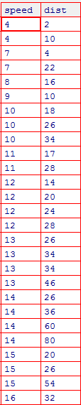

b. Top Speed (SP) and Weight (WT)

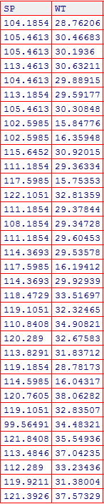

Q2) Draw inferences about the following boxplot & histogram.

**Hint:** [Insights drawn from the plots about the data such as whether data is normally distributed/not, outliers, measures like mean, median, mode, variance, std. deviation]





Q3) Below are the scores obtained by a student in tests

**34,36,36,38,38,39,39,40,40,41,41,41,41,42,42,45,49,56**

1. Find mean, median, variance, standard deviation.
2. What can we say about the student marks? [**Hint**: Looking at the various measures calculated above whether the data is normal/skewed or if outliers are present].

Q5) What is the nature of skewness when mean, median of data is equal?

Q6) What is the nature of skewness when mean > median?

Q7) What is the nature of skewness when median > mean?

Q8) What does positive kurtosis value indicates for a data?

Q9) What does negative kurtosis value indicates for a data?

Q10) Answer the below questions using the below boxplot visualization.



What can we say about the distribution of the data?

What is nature of skewness of the data?

What will be the IQR of the data (approximately)?

Q11) Comment on the below Boxplot visualizations?



Draw an Inference from the distribution of data for Boxplot 1 with respect Boxplot 2.

**Hint**: [On comparing both the plots, and check if the data is normally distributed/not, outliers present, skewness etc.]

Q12)



Answer the following three questions based on the boxplot above.

1. What is inter-quartile range of this dataset? [**Hint**: IQR = Q3 – Q1]

In one line, explain what this value implies. (**Hint:** Based on IQR definition)

1. What can we say about the skewness of this dataset?
2. If it were found that the data point with the value 25 is 2.5, how would the new boxplot be affected?

(**Hint:** On changing the data point from 25 to 2.5 in the data, how is it different from the current one.)

Q13)



Answer the following three questions based on the histogram above.

1. Where would the mode of this dataset lie? **Hint:** [In terms of values On Y-axis]
2. Comment on the skewness of the dataset
3. Suppose that the above histogram and the boxplot in question 2 are plotted for the same dataset. Explain how these graphs complement each other in providing information about any dataset. **Hint:** [Visualizing both the plots, draw the insights]